**HomeWork#3**

20191128 Jian Park

**Environment :**

|  |  |  |
| --- | --- | --- |
| **Hardware** | **OS** | **Used Libraries** |
| MacBook Pro (16-inch, 2019)  2.3GHz 8-core Intel Core i9  16GB 2667 MHz DDR4  Intel UHD Graphics 630 1536MB | macOS Big Sur (11.6) | socket, sys, thread in python2 |

**Compilation commands:**

I’m used python. So pleased command ‘python server.py proxy <port number>’

ex) python server.py proxy 8001

(Please Don’t use python3! If you use python3 it maybe decode or encode error)

If port is already using, it will be an exception. Please retry

When you done, please enter ‘^C’ or another key.

**Implementation details:**

I made 5 functions. The detail of each function is as follows. And please refer to the comments in code.

It similar to hw2, But some details are change. Unlike hw2, I remove all decode() and encode().

**main ()**

It is main function. Server initialization (make socket, bind, listen). If port is already using, it will be an exception.

And Client initialization while keyboard interrupt.

For multiplexing, used thread that add start_new_thread()

**parsing_request (client_sock, read_bytes)**

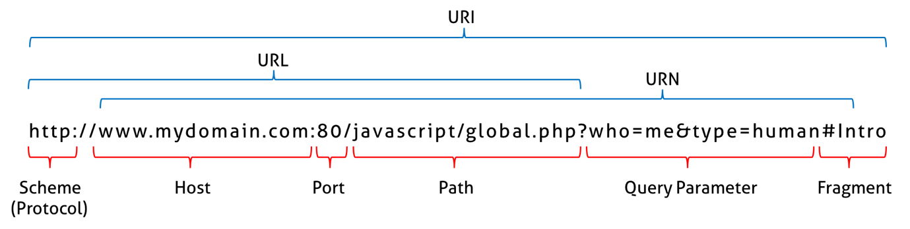

This function is parsing client request message and determine whether to request to server or not.

I want to export host, port in client request message. So it split protocol first, and split ‘:’ and ‘/’.

It parsing is done, check if it cached.

Is valid(HIT), send response to client in cache. Else request to server.

If method is not ‘GET’, it response 501 error

**check_cache (url)**

It is check is in cache. If file that named url is exist, it cached. Return response message in the cache.

Else retune None

**request_server(url, domain, port, client_sock, read_bytes)**

Reques to sever. Make socket to connection origin server. Receive response as much as the buffer size and send client. When received all message. save in the cache.

**save_cache(url, server_Read_bytes)**

Save response message in cache. Make file that named url, and write message.

**Result:**

1. Koreatimes.co.kr



Figure . browser

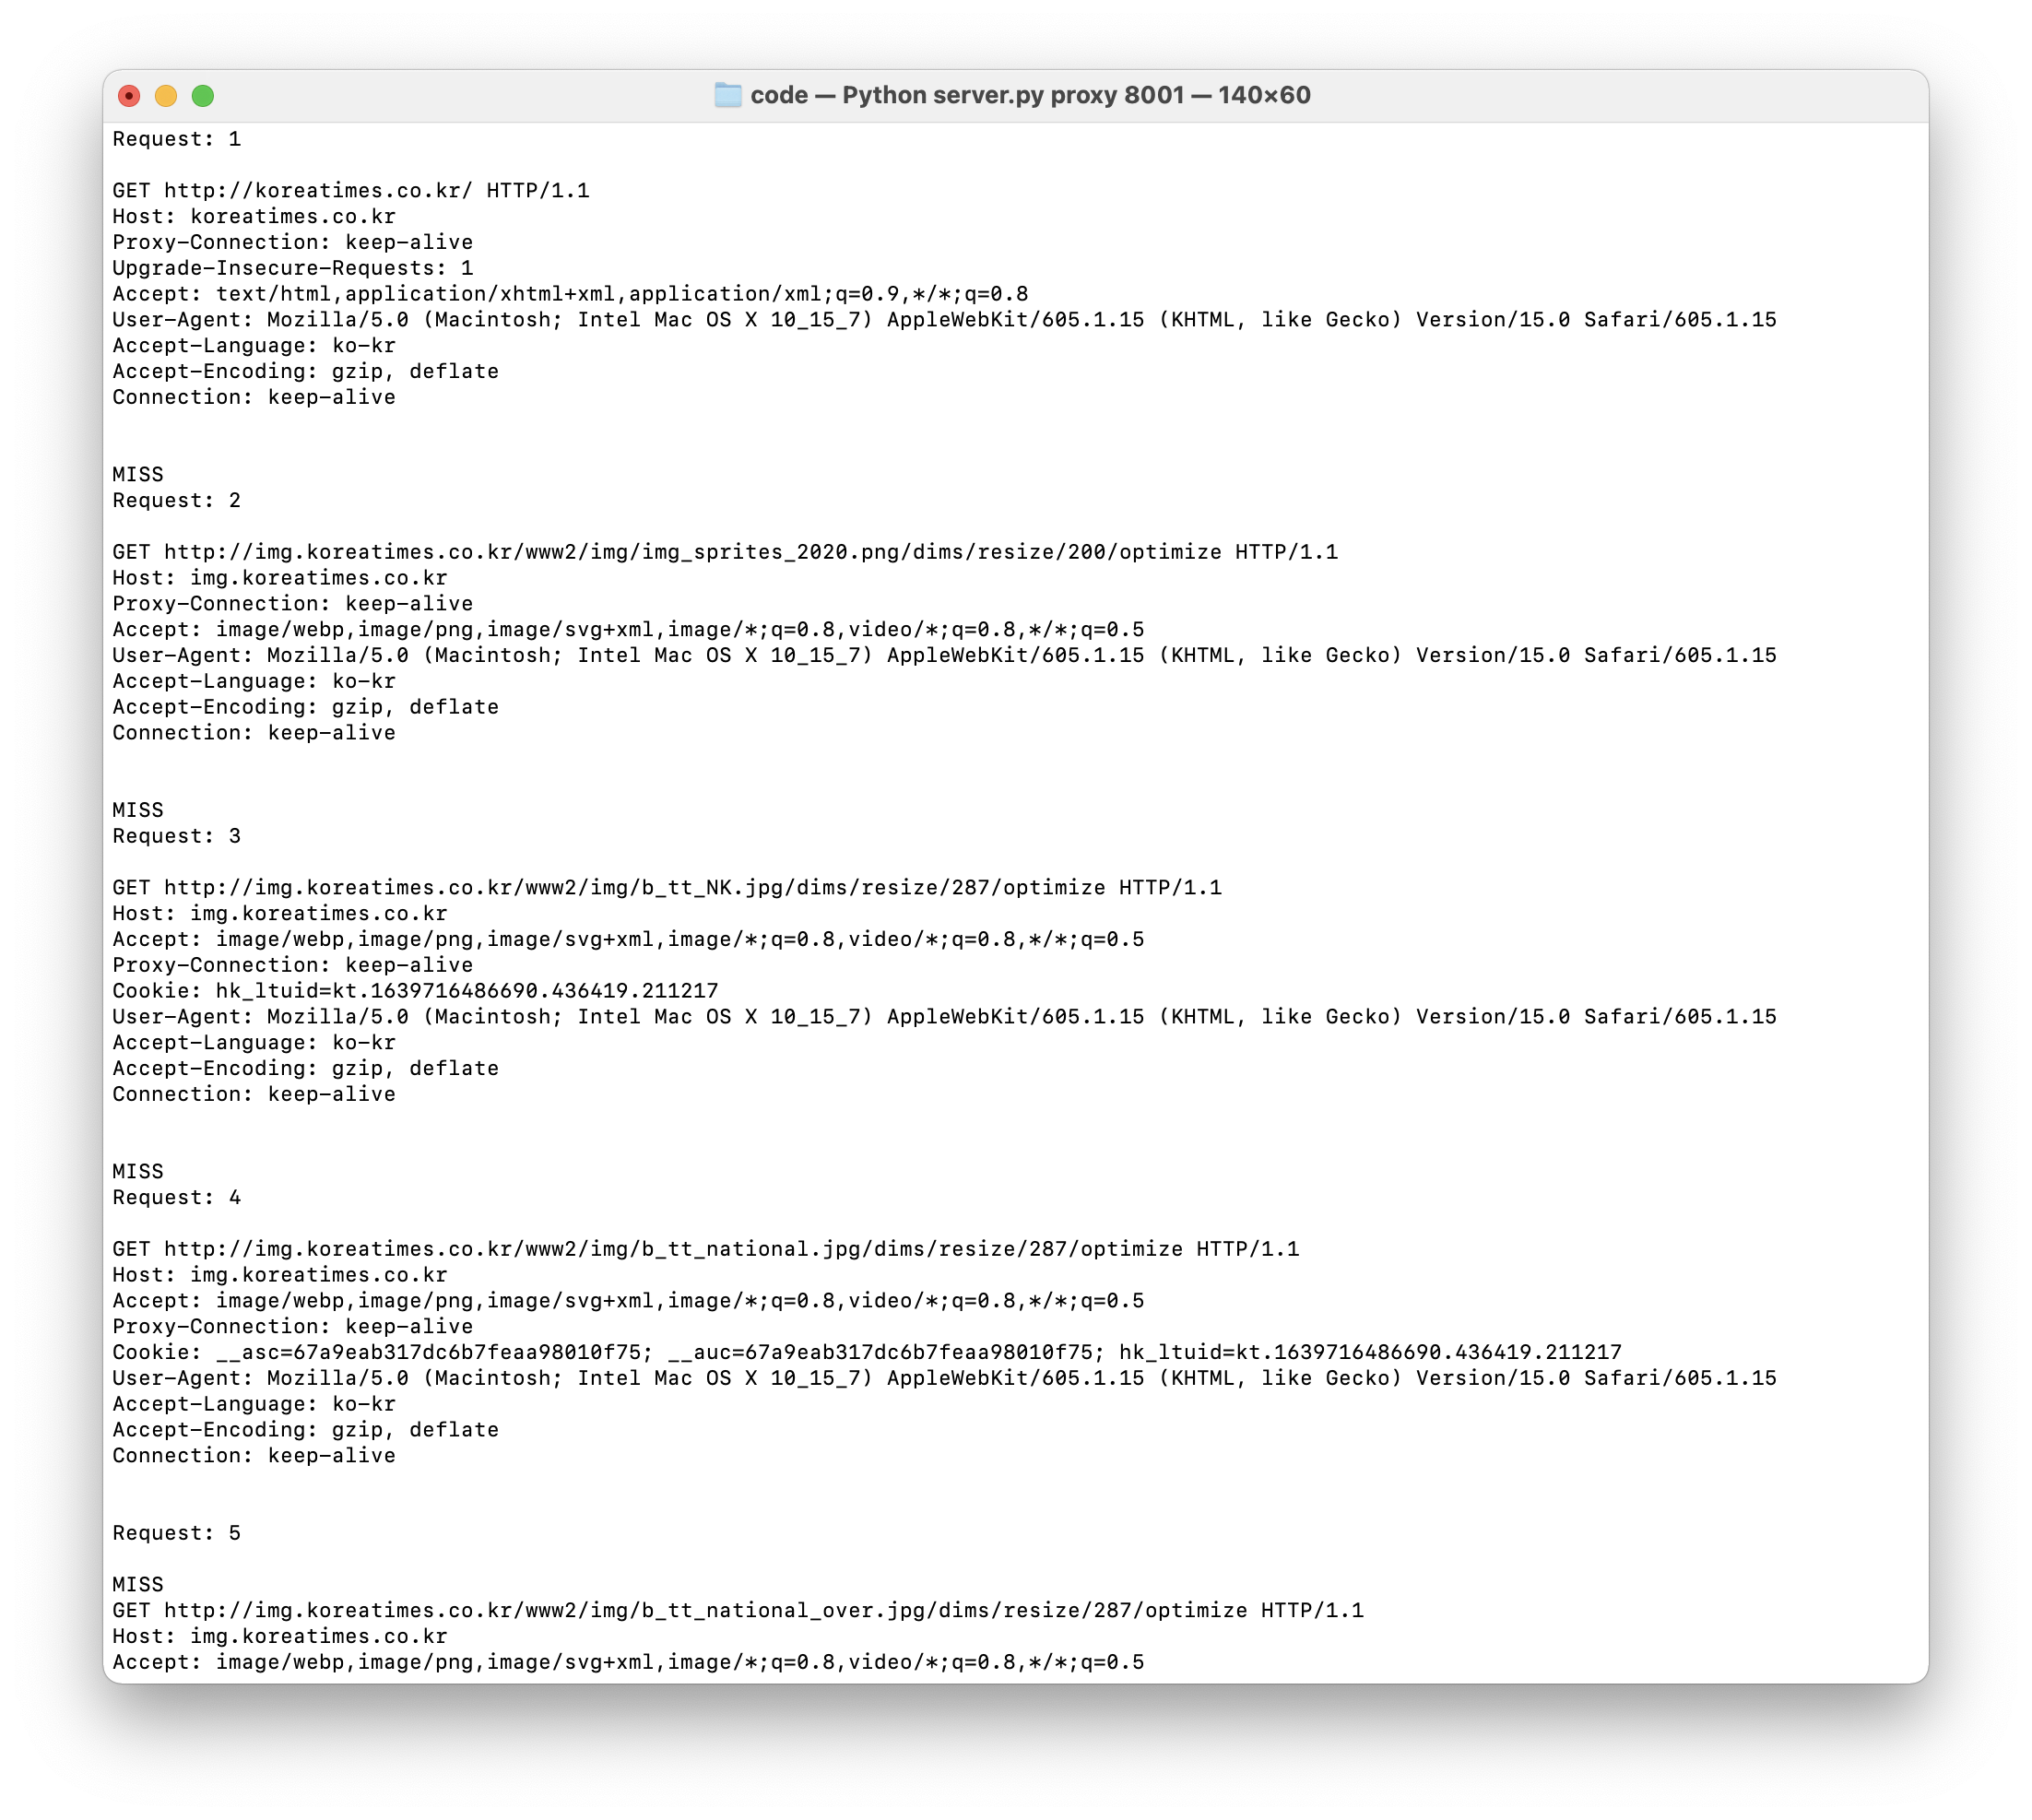

figure . Request & Response

It can be seen that multiplexing is implemented through consecutive requests and responses.

1. korea.ac.kr

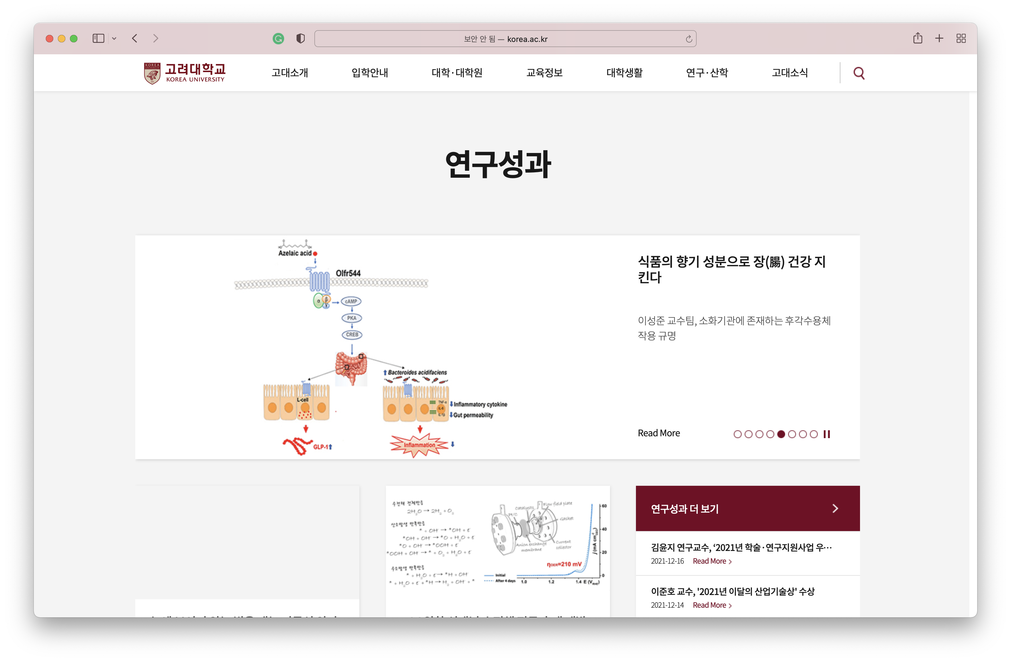

figure . browser

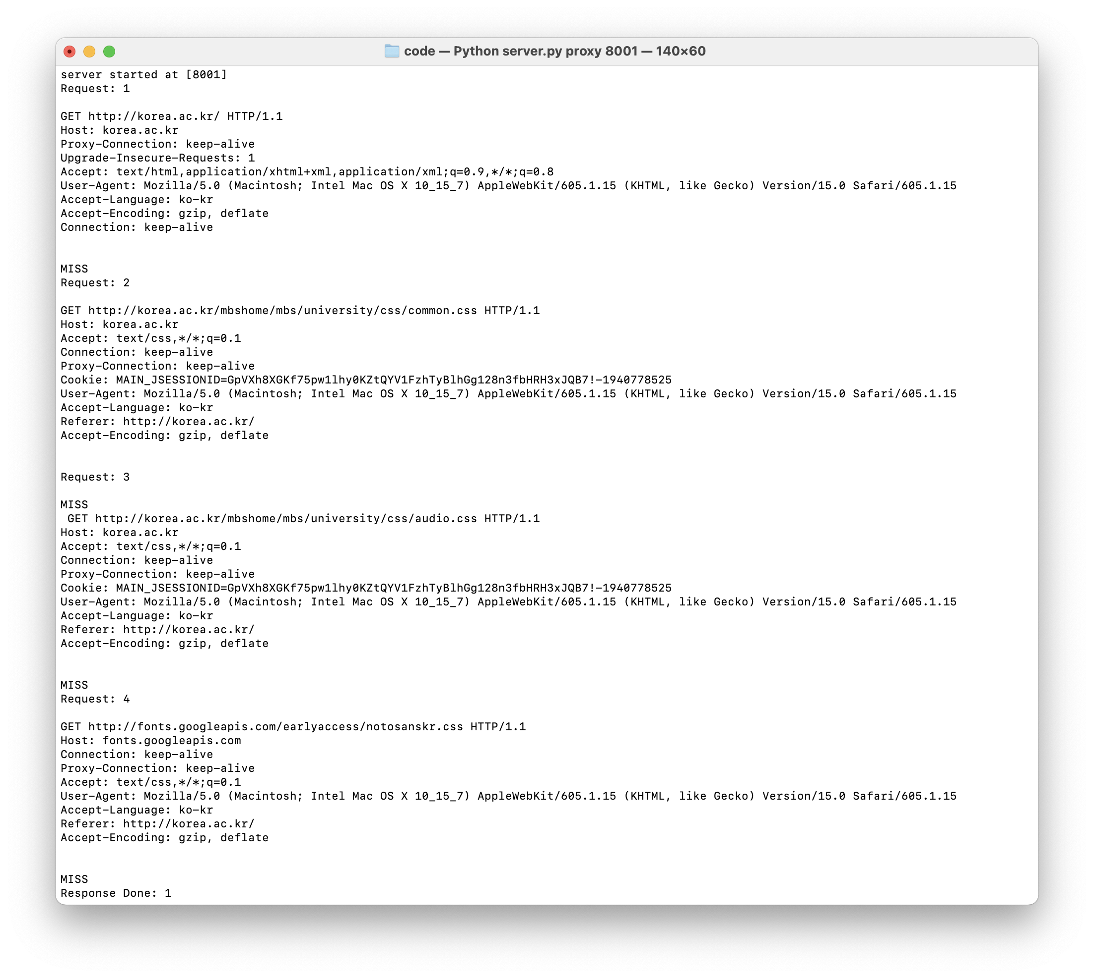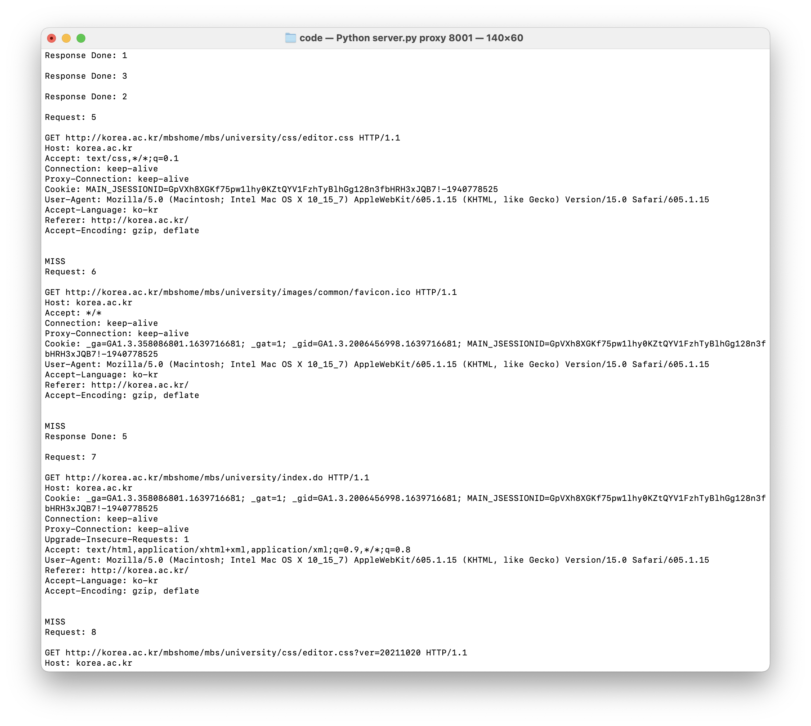

figure . Request & Response

It can be seen that multiplexing is implemented through consecutive requests and responses.

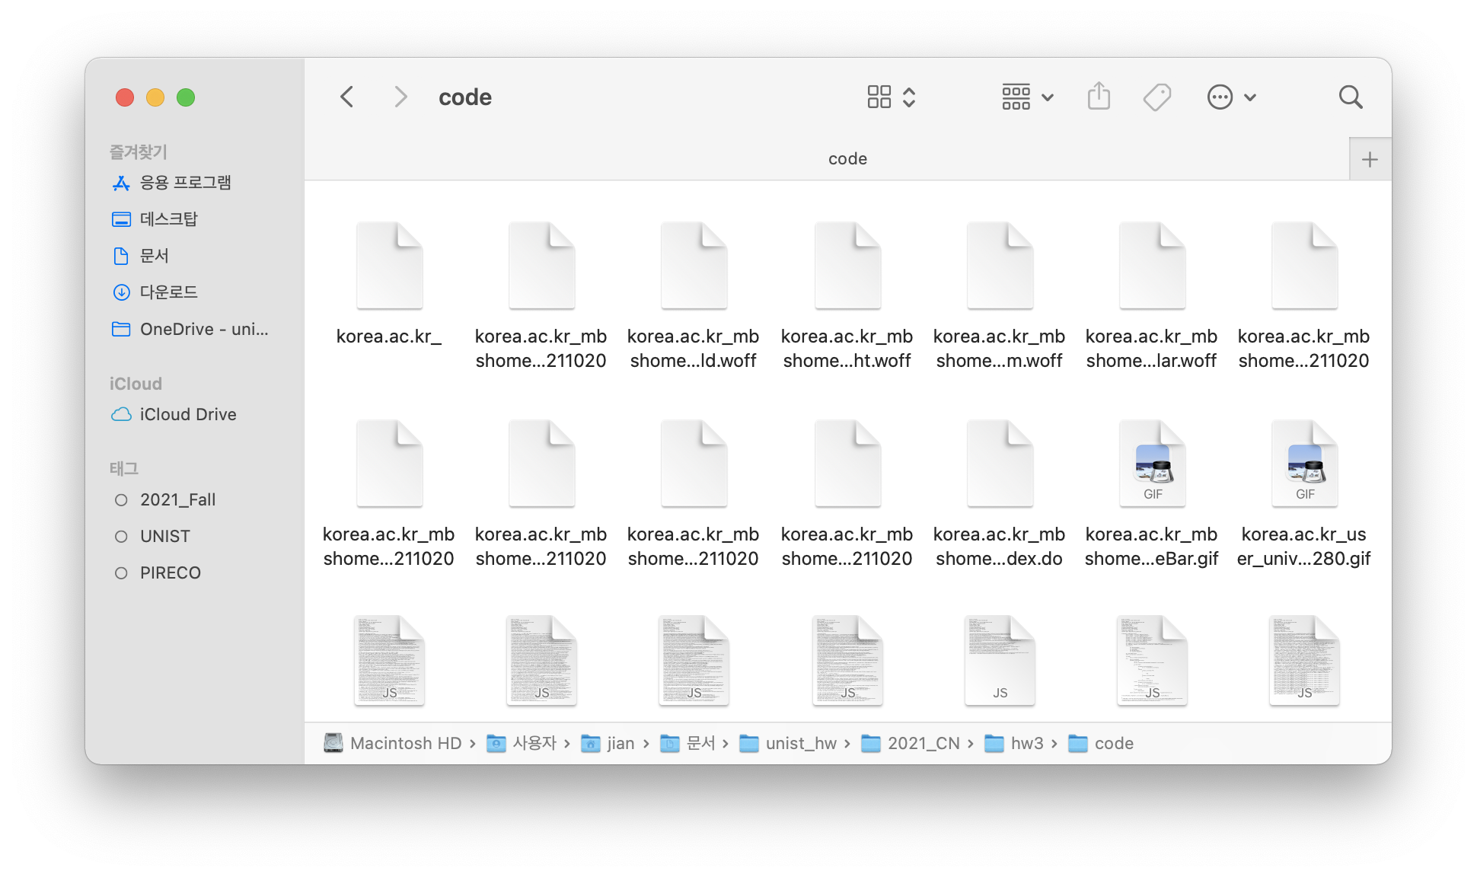

figure . Cache files

1. danawa.com

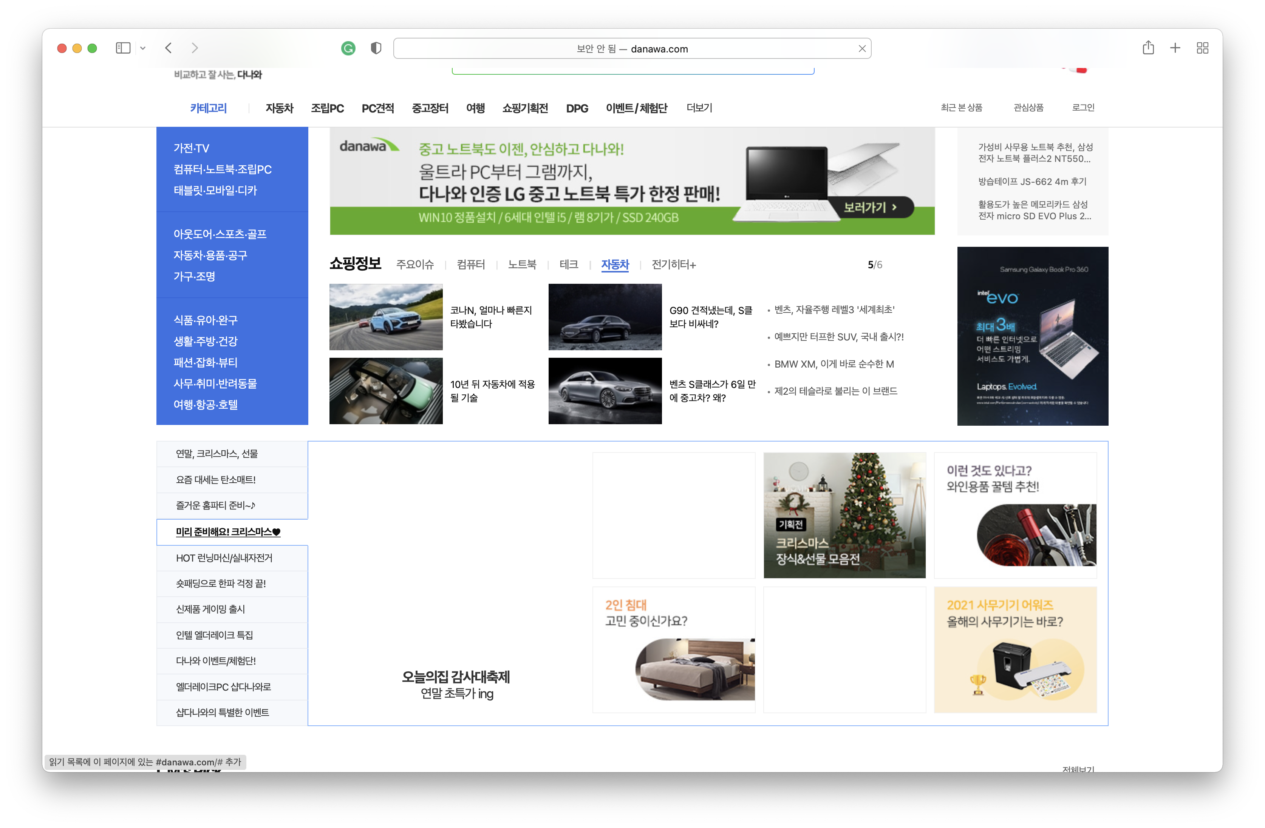

figure . browser

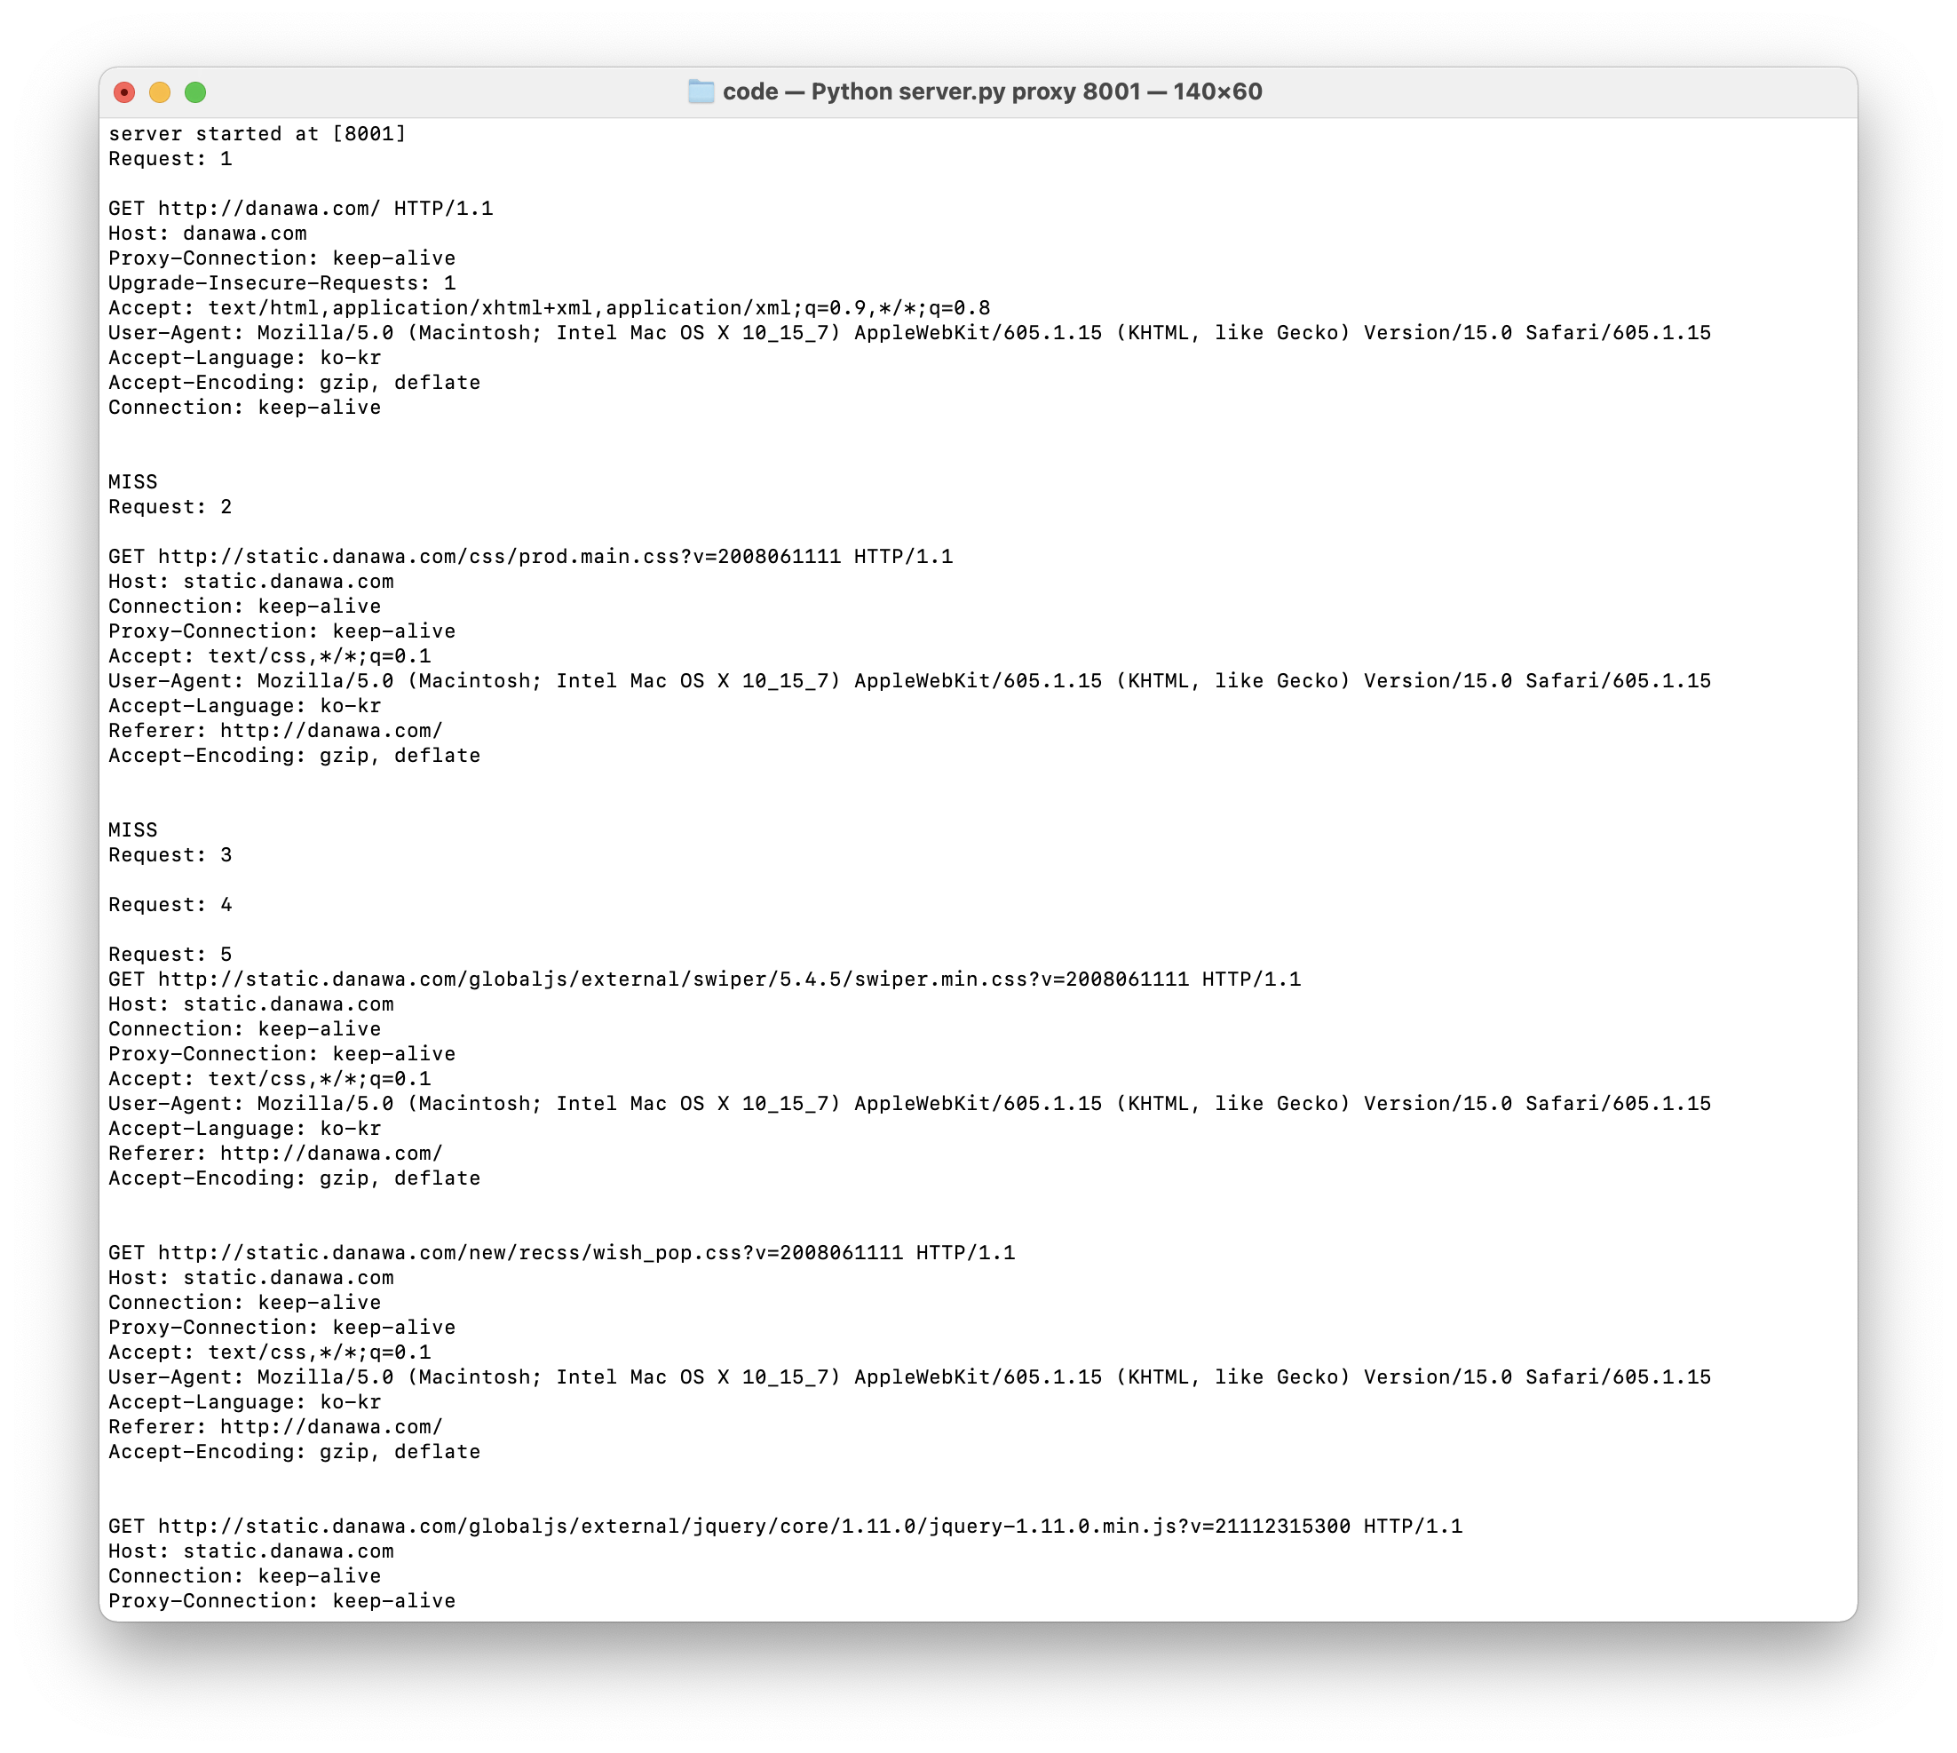

figure . Request & Response

It can be seen that multiplexing is implemented through consecutive requests and responses.

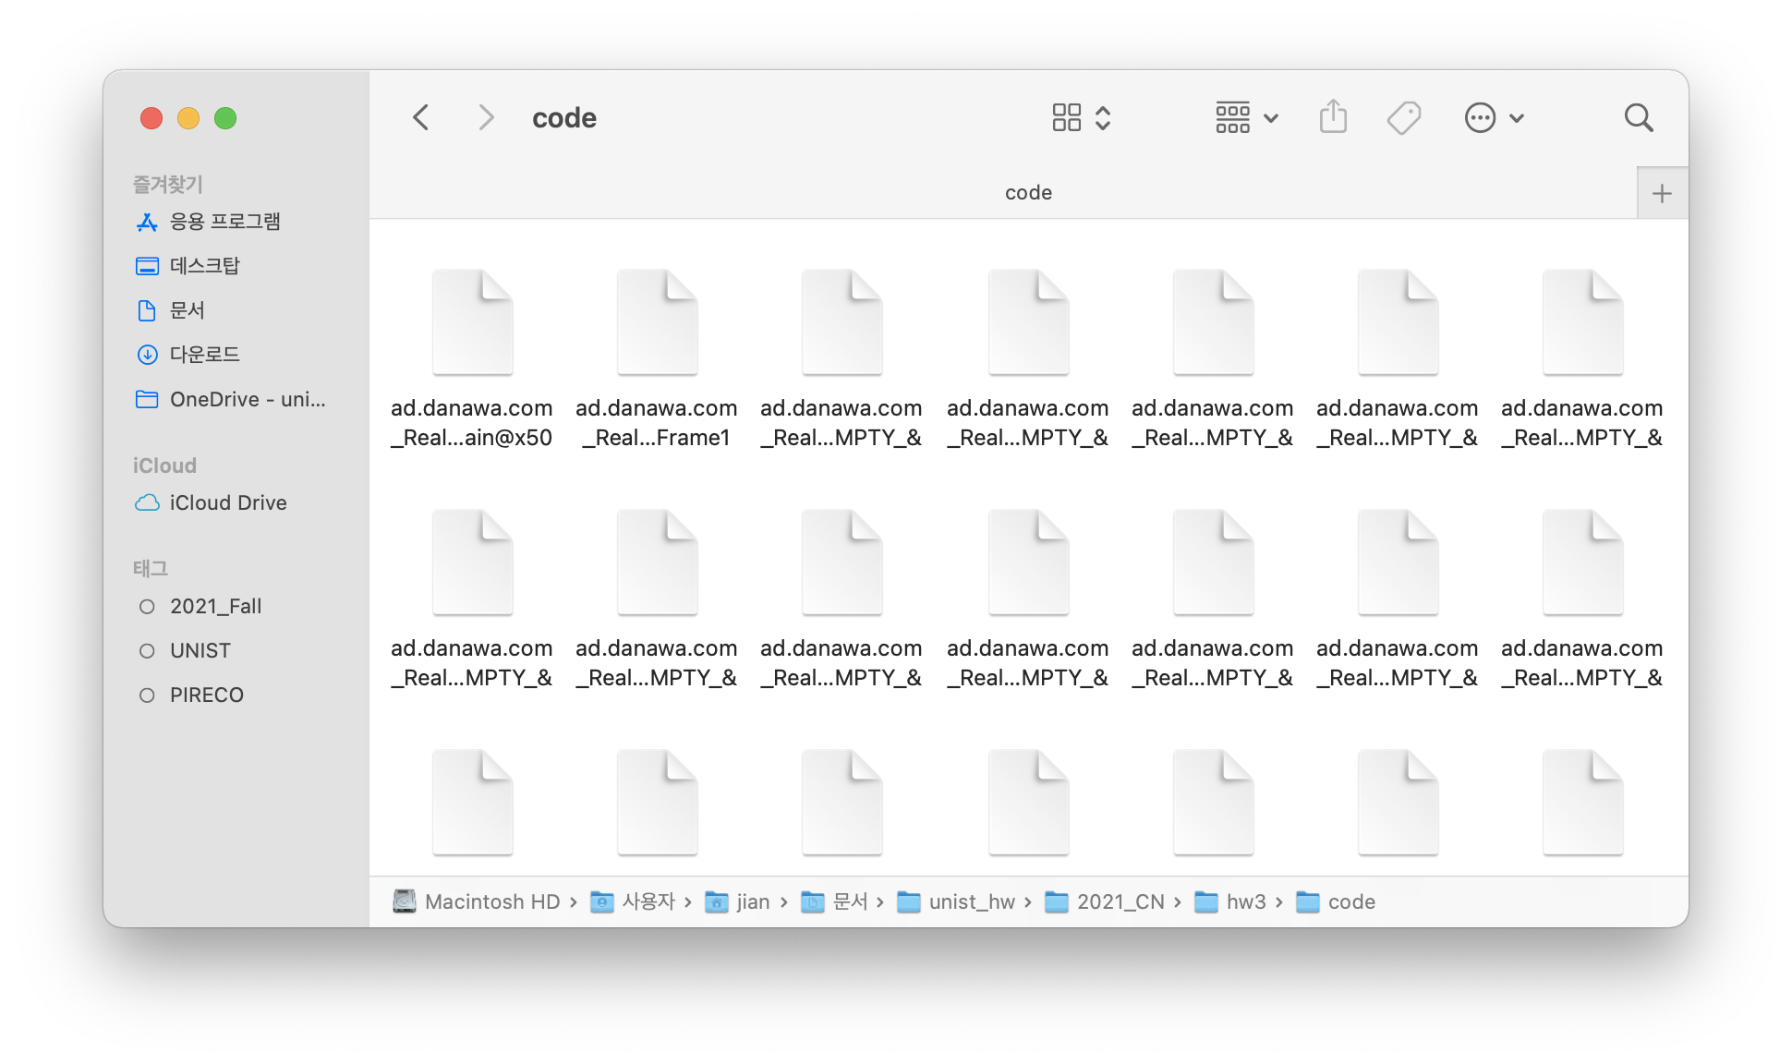

figure . cache files